A push to stay at the VA
By ERIN SCHUMAKER and CARMEN PAUN

01/09/2025 02:00 PM EST

THE NEXT CURES
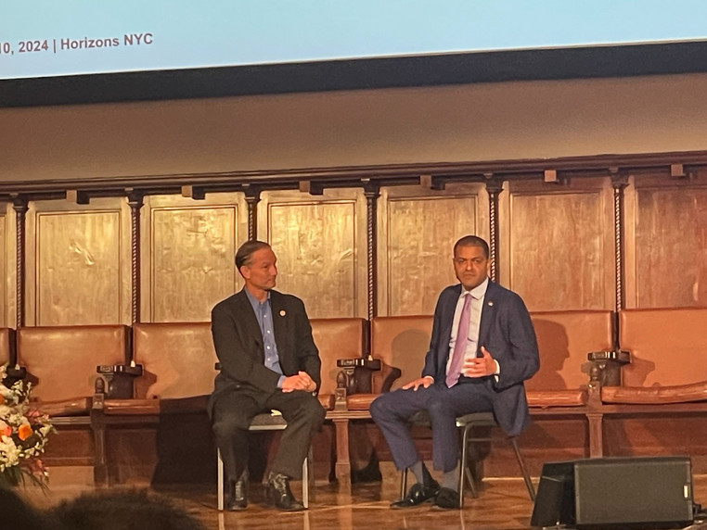
Veterans and psychedelics advocates are lobbying to keep Dr. Shereef Elnahal at the VA. | Erin Schumaker/POLITICO
Dr. Shereef Elnahal wants to keep his job as undersecretary for health at the Department of Veterans Affairs.
An advocate of psychedelics as a mental health treatment, he’s making the case that his own interest in the drugs dovetails with that of President-elect Donald Trump’s pick to lead the Department of Health and Human Services, Robert F. Kennedy Jr.
Elnahal’s popular among veterans and psychedelics advocates, who are making calls this week to encourage lawmakers to lobby Trump to keep Elnahal on.
The odds of that are long. Elnahal is a Biden administration appointee and Trump has largely tapped loyalists and celebrities to staff his administration.
“I haven’t been asked to stay, but if I am asked, I would stay,” Elnahal told POLITICO. “I’d be honored to continue on and advance the agenda for veterans.”
While Trump hasn’t publicly commented on psychedelics, Elnahal is heartened by what he’s heard from Kennedy, who has openly criticized the Food and Drug Administration’s approach to regulating the mind-altering drugs. The FDA this summer rejected a drugmaker’s application to offer the psychedelic drug MDMA, alongside therapy, as a post-traumatic stress disorder treatment.
“The public statements from Bobby Kennedy on this have been very encouraging,” Elnahal said.
Kennedy said his mind was open “to the idea of psychedelics for treatment,” in a post to X in September, adding that “People ought to have the freedom and the liberty to experiment with these hallucinogens to overcome debilitating disorders.”
“I really appreciate Bobby Kennedy’s approach to trying to instill wellness as a bigger part of American life — I think veterans would benefit from that,” Elnahal said, adding, “When it comes to breakthrough therapies for mental health and tackling veteran suicide, psychedelics fall straight into that agenda.”
Still, some are skeptical that the hype around psychedelic medicine has outpaced the science behind it, and worry that the drugs could be misused or could put patients at risk.
Why it matters: A year ago, the VA announced it would fund psychedelic research on post-traumatic stress disorder and depression for the first time since the 1960s.
Thousands of veterans, many of whom have PTSD or depression, travel to other countries to seek psychedelic-assisted therapy each year. Given that, Elnahal thinks the United States should be offering those therapies in well-controlled settings.
“The only way to do that is to boldly approach this with more research and to give veterans access to this kind of therapy here at home,” he said. “You shouldn’t have to travel to Mexico. You shouldn’t have to travel to Costa Rica. We really need a line of sight into this type of therapy to make sure that it’s effective.”
“I think the incoming administration has the right mindset on developing that evidence and delivering it safely to veterans.”

